1. Bot will enter the URL - <https://pa.powys.gov.uk/online-applications/?lang=EN>

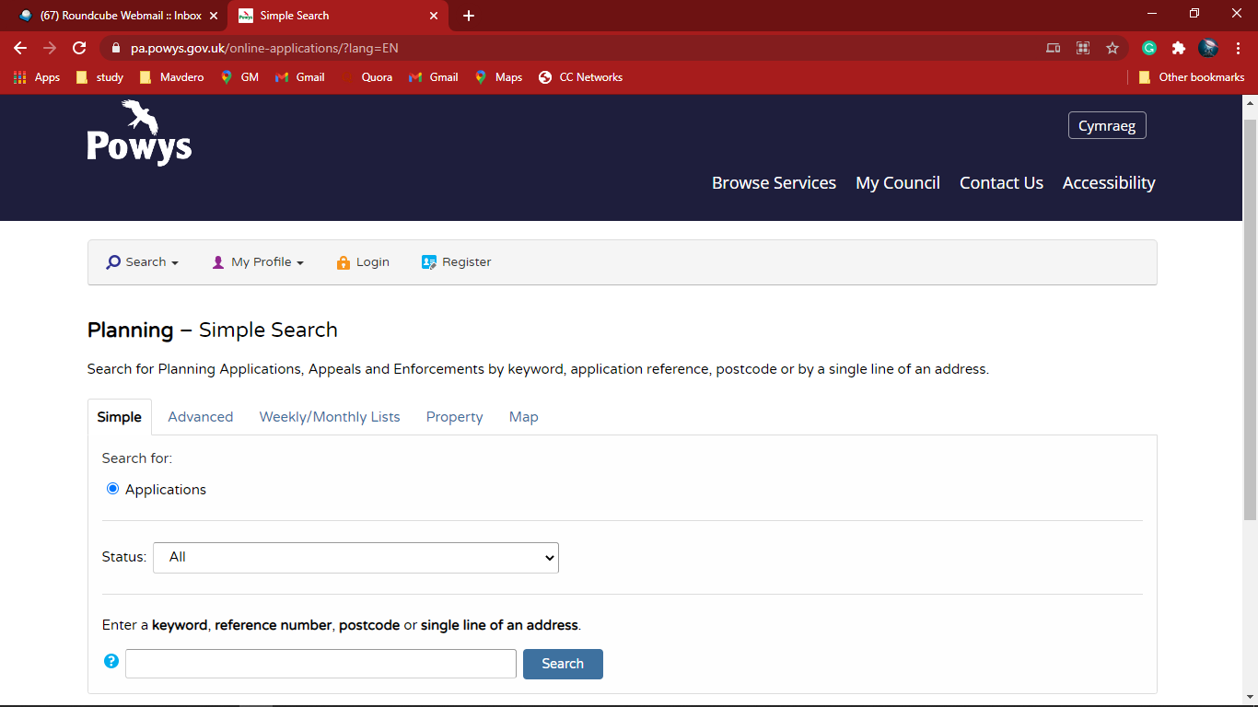

1. Bot will select All in Status manu

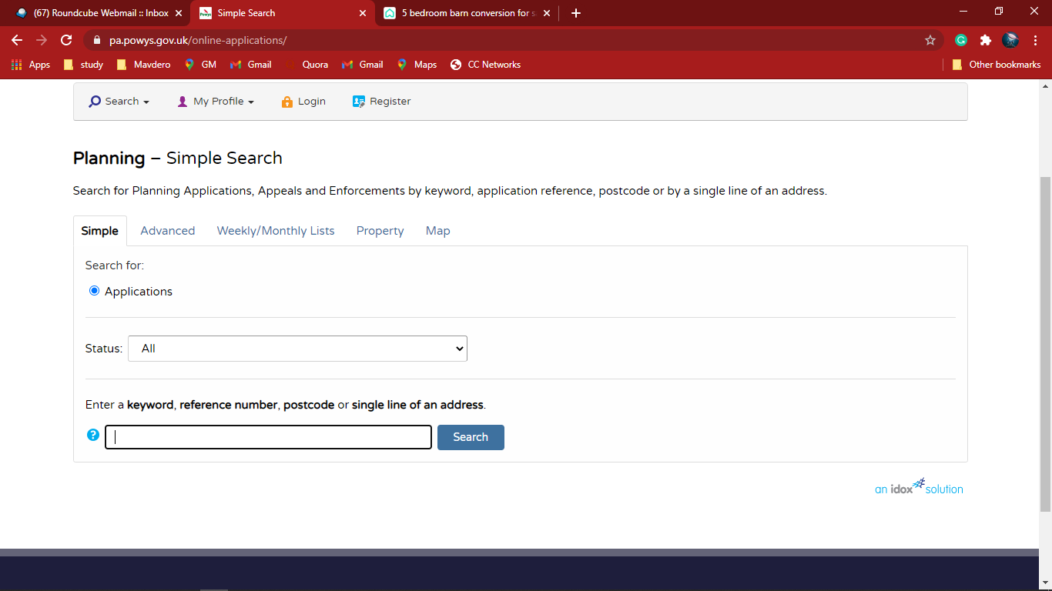

1. Bot will enter the Address line and click Search

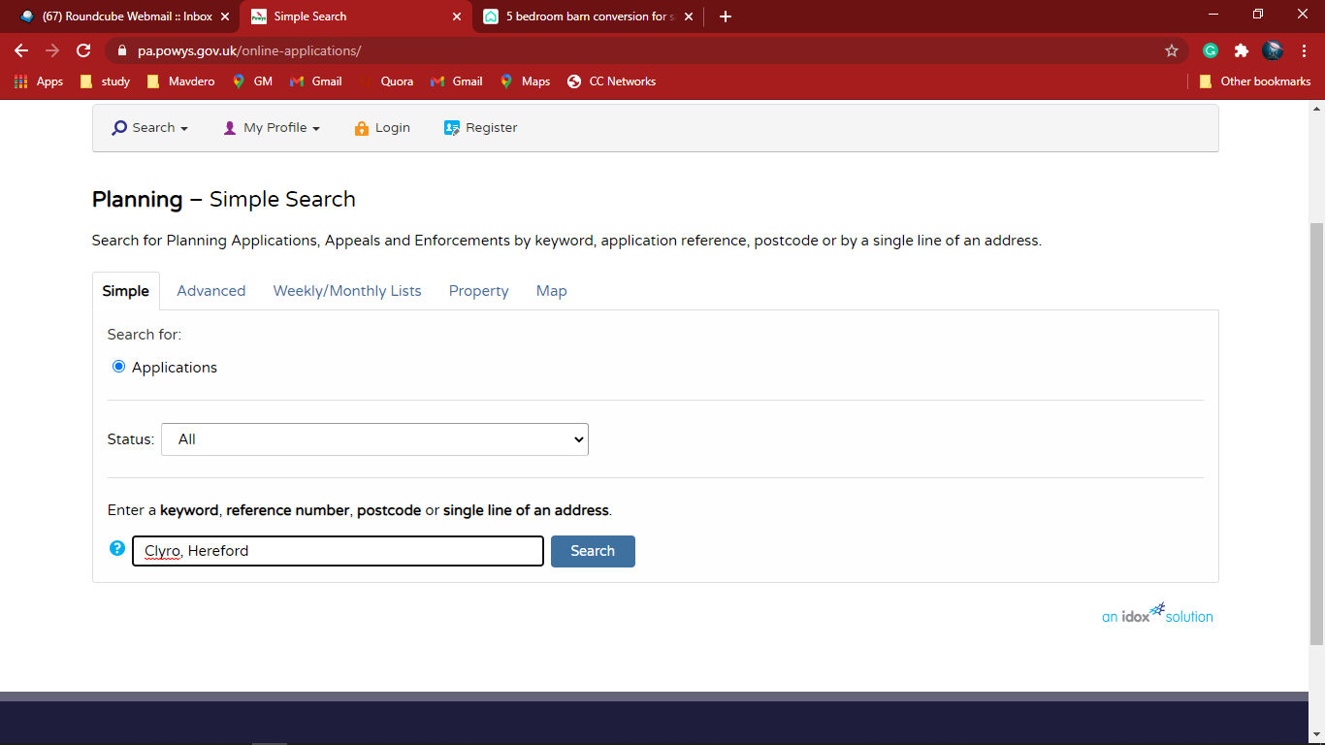

1. Bot will select the correct Address

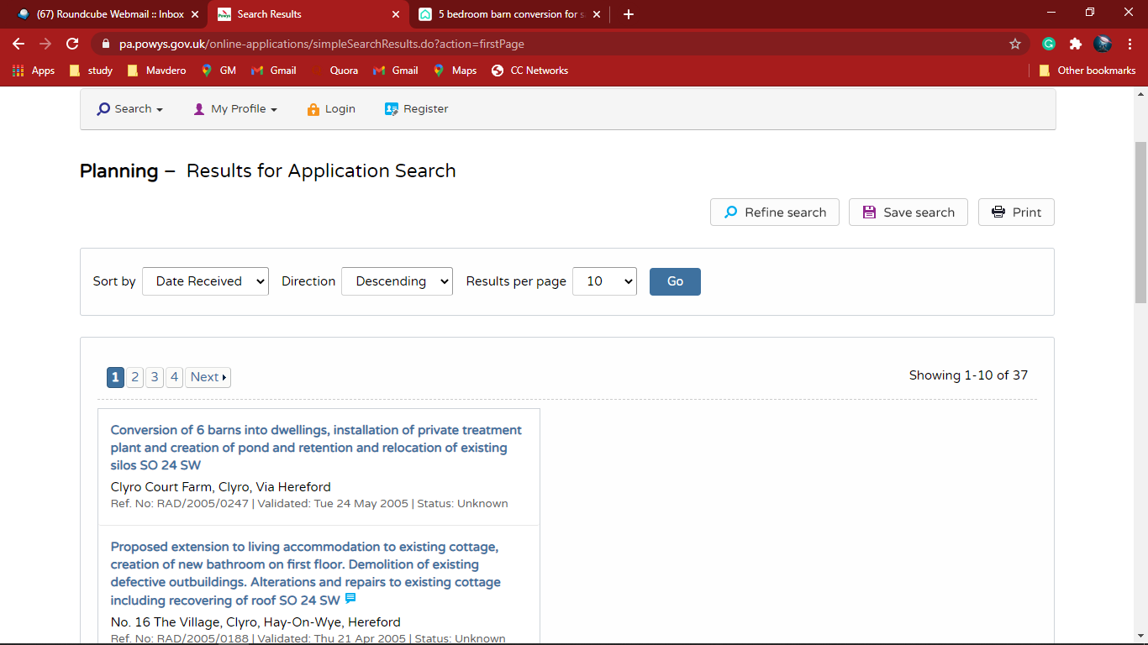

1. The Planning - Application summary will show as follow

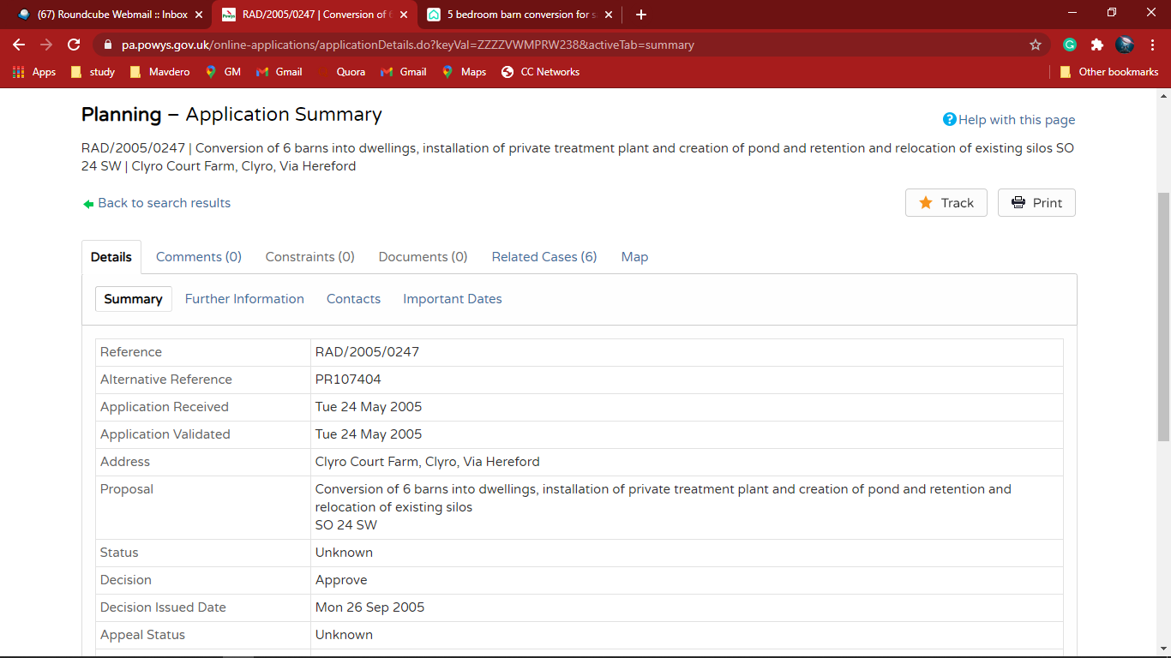

1. Bot will click and go to the Important Dates

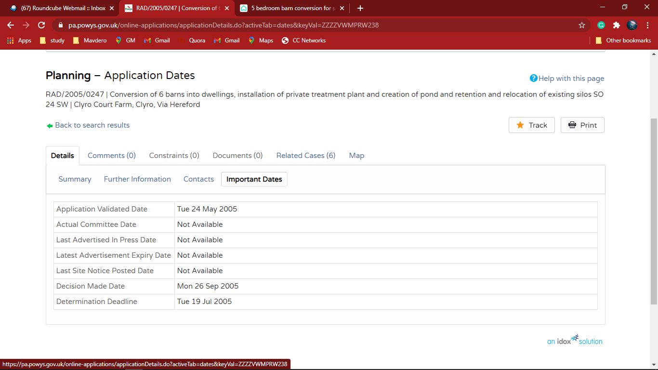

1. Bot will Extract the data form Important date and populate in excel

